Week 4 Result

Multilayer Perceptron & Financial Market Indexes
Hidden Layer 1: 968 neurons
Hidden Layer 2: 484 neurons (≈ half of 968)
Epochs: 10

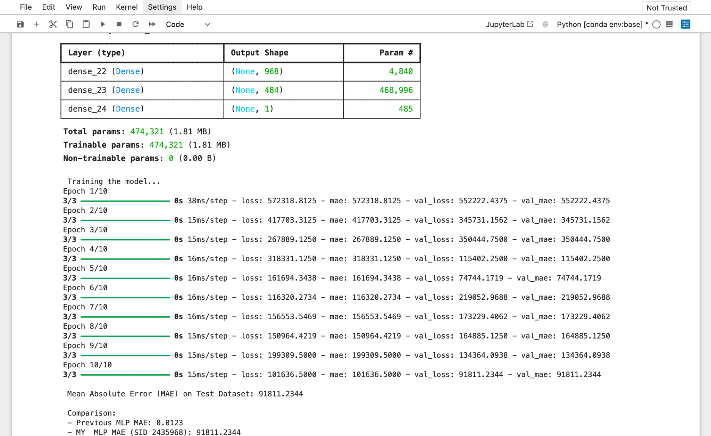

CODE
